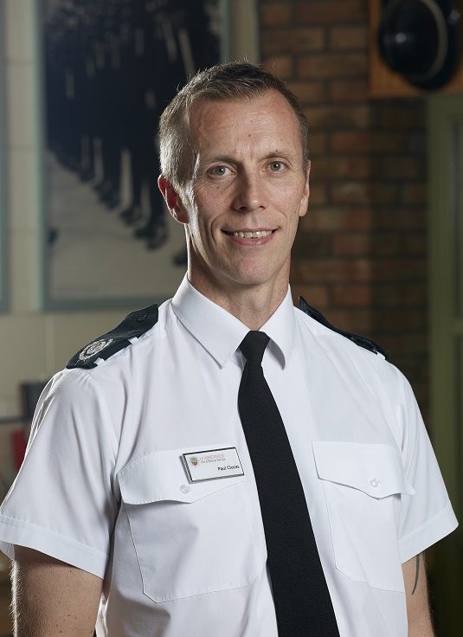**Paul Clucas**

***Making a Difference***

**CONTACT INFORMATION**

07801 926367



clucasp@yahoo.co.uk

**EDUCATION & QUALIFICATIONS**

**BSc (Hons) Safety and Environmental Management (1st Class)**

University of Hull | Feb 2009

**Level 5 qualification in Leadership and Management – 2014**

**Civil Emergency and Disaster Management - 2018**

Auditor, Accident Investigator, Silver Command and Control, IOSH Trainer, Trauma Care Trainer, Advanced level response driver, Incident Debrief Co-ordinator,

**NOTABLE ACHIEVEMENTS**

**Chartered Safety and Health Practitioner (CMIOSH)** | Dec 2009

**Level 2 Triathlon Coach 2021**

**TECHNICAL SKILLS**

* Risk Management
* Command and Control
* Conflict Management
* Business Continuity
* Strategic Planning
* Project Management
* People Management
* Training & Development
* Performance Management
* KPI Management
* Client Engagements
* Customer Service
* Budgetary Control
* Rospa QSA audit
* Health and Wellbeing Support
* Microsoft Suite

**PERSONAL SKILLS**

* Leadership
* Reliability
* Integrity
* Innovation
* Dignity
* Decisive Decision Making

**P E R S O N A L P R O F I L E**

Having worked for the Fire and Rescue Service for 30 years, supplemented with 18 years working for a local charitable Housing Association, combined with my academic qualifications, I have gained extensive knowledge, experience and exposure to a vast array of dynamic and challenging situations. A highly proactive, can do, results-focused individual, with strong communication and leadership capabilities, I am now looking for a fresh challenge following retirement from the Service and an opportunity to utilise my skills and make a positive difference.

**E M P L O Y M E N T H I S T O R Y**

**Head of Health, Safety and Environment, Service Support and Estates**

Humberside Fire and Rescue Service| July 1992 – Retire Feb 2022

**Responsibilities & Achievements:**

* Lead on all HSE matters, determining and implementing the strategy, determining and detailing the procedures, policies, guidance, position statements, supporting hardware and software for the delivery of HSE and implementing that delivery with Heads of Function to embed risk management.
* Work with the NFCC and others, regionally and nationally, to translate national direction, standards (including NOL/JOL) into HFRS strategy, policy and delivery, leading and supporting employees and others through change management. Maintain up-to-date information on legislation, Codes of Practice and guidance, collating and interpreting such information and communicating this to management and employees through appropriate channels.
* Chair internal and external groups to lead on improvements, including the Change Group and the Estates Group, acting as the Single Point of Contact for the Joint Estates Service.
* Support the implementation and ongoing improvement of the Environmental strategy across HFRS, including effective risk management
* Determine the approaches for the delivery of a proactive and positive health and safety culture activity.
* Act as the Authority’s Principle ‘Competent Person’ as defined in the Management of Health and Safety Work Regulations 1999.
* Effectively manage any delegated budgets and have responsibility for capital and revenue bid/programmes within the Directorate. Manage and oversee the service budget for HSE delivery and Service Support
* Provide professional advice to all levels of the Authority, on all Health and Safety related matters to enable the Authority to fulfil its legal obligations.
* Manage the development, consultation, implementation, monitoring, auditing and where necessary review and revision of all health and safety related policies, procedures and practices, to ensure effective arrangements for all aspects of Health and Safety within the Authority and its undertakings.
* Manage and maintain the Authority’s reporting system for collation, analysis and circulation of information, including for adverse Health and Safety related events and trend analysis (i.e. accident, near misses etc.). Ensure systems are in place for the relevant statutory bodies to be informed of notifiable accidents, injuries, diseases, and dangerous occurrences as required by legislation.
* Lead on management level investigations and prepare reports with conclusions and recommendations to prevent any reoccurrence, including analysing accident & near miss data, designing strategies for reducing accidents and injuries at work in line with the Governments ‘Revitalising Health and Safety’ strategy and other initiatives.



* Business Continuity
* First Aid Instructor (Trauma)
* Hazardous materials advisor
* Water incident manager
* Accident and loss investigation
* Restorative practice
* Managing conflict
* Harassment and bullying
* Discipline regulations

**HOBBIES AND INTERESTS**

**Triathlon, Football, Rugby, Rowing, Mountain Biking and family pets**

**ADDITIONAL EMPLOYMENT HISTORY:**

**Health and Safety Manager**

Hull Churches Housing Association | May 1998 - Sep 2016

**Responsibilities & Achievements:**

* Manage the day to day Health and Safety across all sites
* Review and monitor policies, procedures and guidance in relation to Health and Safety
* Ensure staff have suitable training for their role and refresh training at frequent intervals
* Undertake risk assessments and fire risk assessments in communal parts of tenant accommodation
* Undertake risk assessments and fire risk assessments on office-based locations
* Act as the Authority’s Principle ‘Competent Person’ as defined in the Management of Health and Safety Work Regulations 1999.
* Maintain the Health and Safety management system to HSG65 standard
* Undertake testing to comply with the Legionella Regulations
* Undertake accident and near miss investigations to reduce the risk through learning and provide periodic reports for the Board

Additional context to my areas of responsibilities above is embellished further in the detail below:

Lead the Service in all matters relating to health, safety and environment including the principles of risk management, implementing organisational training in across two blue light organisations, for both H&S and the Environment. Initially acting as lead trainer and more latterly as assurance, challenge and support.

Driving the safety culture through engagement and operational ownership of safe working practices, from a blame culture to a trust/learning culture. Integral in overseeing organisational learning from both internal operational assurance processes and external events, whilst representing the Service at National and Regional levels to ensure a Nationally accepted Analytical Risk Assessment process.

Delivering the findings of a significant incident investigation to numerous other Fire and Rescue Services across the country to share and enhance sector organisational learning. Establishment, lead and implement the UK’s first H&S collaboration between Fire and Police, establishing a joint Health and Safety Service, remaining responsible for the overall management and continuous development of the team, multi-agency relationship and agreement.

In addition, my portfolio included the management of the Service Support function and Joint Estates Service within the organisation, with a combined annual budget of £5m. During my time I successfully managed the build of three new Stations and renovations across the entire estate. I also successfully challenged the Health and Safety Executive to enable the Fire Service Nationally to utilise step ladders for community work when threatened with a prohibition notice. Thereafter building an effective working relationship with the HSE to work constructively moving forward.

Implementation of the first Environmental Strategy across the organisation. Initiating a cross organisational representative working group to champion ideas and drive behavioural change across localities with the aim of reducing the organisations environmental impact and promote a more sustainable operating model.

Operationally, I have managed multiple incidents including major multi agency incidents such as widespread flooding, large fires, chemical and RTC incidents as well as major events such as football, celebration events etc. These often involved the chairing multi agency meetings both on scene and at a Silver tactical level. Holding the specialism of Hazardous Materials advisor and more latterly as a National Interagency Liaison Officer working with Police, Ambulance, Military and Special Forces to resolve Counter Terrorism and other multi complex incidents.

I have gained a wide range of knowledge and transferable skills that will be of great value to any employer.